**Roots for Success – Design Notes 16.4.15**

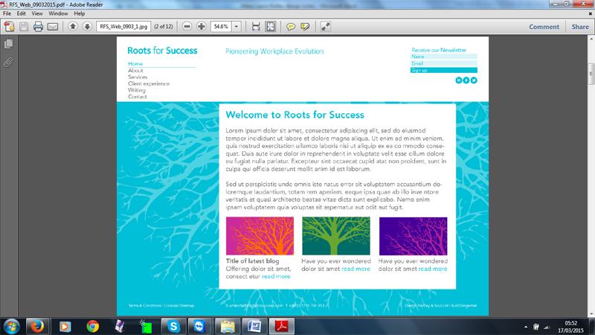

1. Link logo to home page
2. Icons for linked in, twitter and facebook. Only display these if information is entered into cms
3. Signup form. For the time being add the information to database. Later may have mailchimp newsletter
4. Navigation, top left. On about us, services this opens. Current page colour is blue with underline.

If in a section such as real conversations the services is blue and underlined and current page is blue.

1. There is no page for about us and services. Open the navigation and display the first page in the list
2. Footer
   1. Terms and Conditions Simple text page
   2. Cookies one page Simple text page
   3. Design Hartley & Soul links to <http://www.hartleyandsoul.com/> open in new window
   4. Build singernet links to <http://www.singernet.co.uk/> open in new window

**Home page**



Fields

Title  
text box

Module for the sections same as HLR  
each has

* Heading
* Image
* summary text
* link

Home page must not scroll**About Us, Guiding principles, Sub pages of services. All same format**

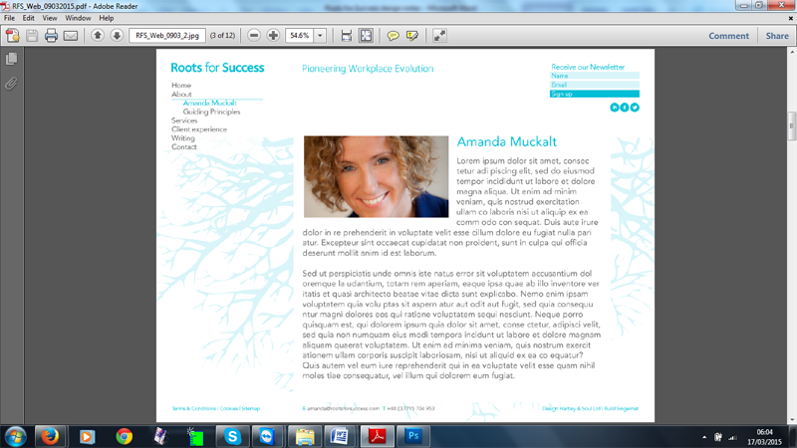

Fields

Title

Image

Textbox.

If no image the text box fills the text area (eg open facilitation)

**Client Experience**

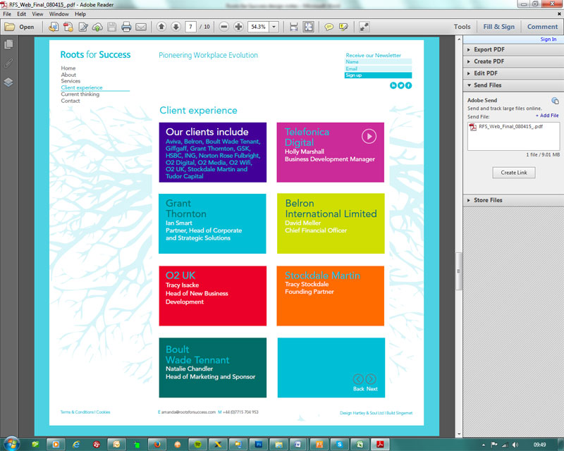

page scrolls

Our clients include - text box with links

Telefonica - this is a youtube video. The title, name, company and video will change

5 clients - these will change. When you click on a client a page like Amanda Muckalt will appear in a popup

Back Next box this will link to another page which looks the same but with different clients, that is there will be many more than 5 clients.

**Current Thinking**

* This is the blog

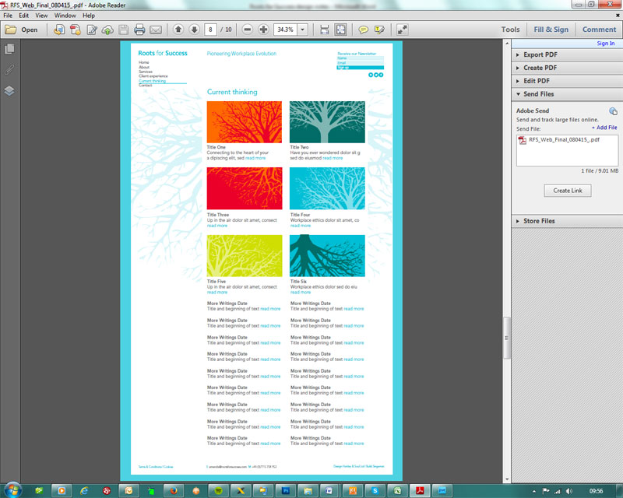

* First 6 items are the latest in the blog
* Other blog items do not display the image
* Each blog item has
  + Title
  + Image
  + Text, the first bit of the text is used for the summary, break on a word
* Entries are displayed in date order, latest at the top

When you click on the image or the title you get to a page like

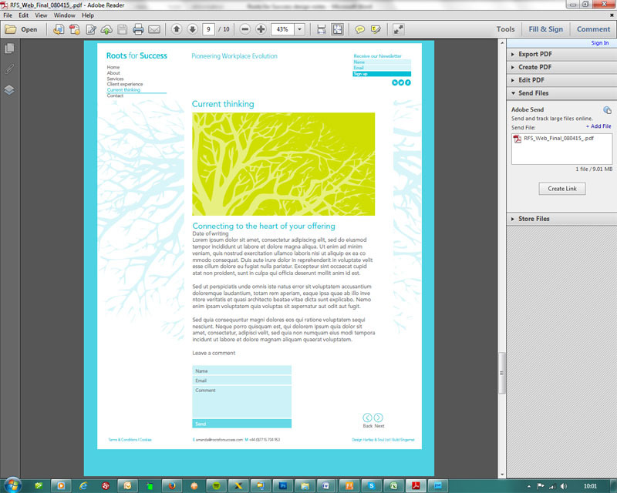

* This is the more information for the blog entry.
* same picture as the previous page, just bigger
* validate form
* Back/next go to the previous or next blog detail entry
* Email Amanda to say comment has been added and needs to be approved

**Contact**

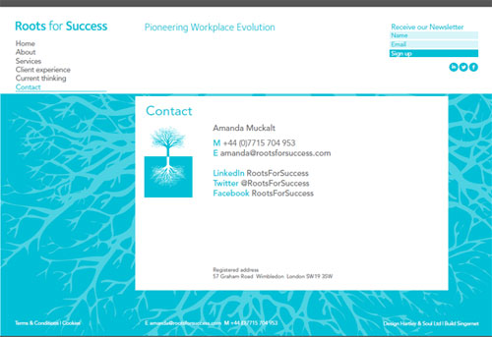

* **Notice that this page and the home page are on the blue root background.**

**Terms and Conditions and cookies**

* These pages will just have one column of text that goes right across the page. No images needed.

**Other things we will need/ Notes**

* We will need 2 big backgrounds to go beneath the pages. One white on blue, one blue on white
* Colours and fonts, including hover for links etc
* It looks much bigger than a normal monitor so it will scroll. Marianne will provide psd at 72 dpi
* Online courses and Retreats – just have page saying coming soon